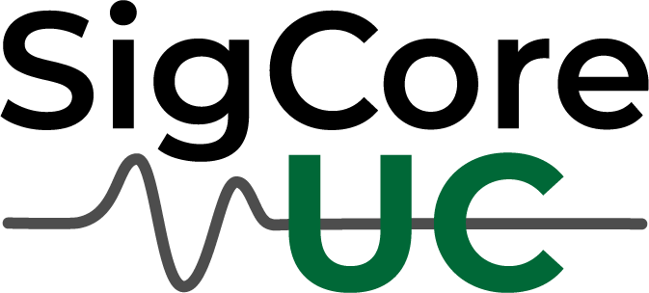

Universal Controller
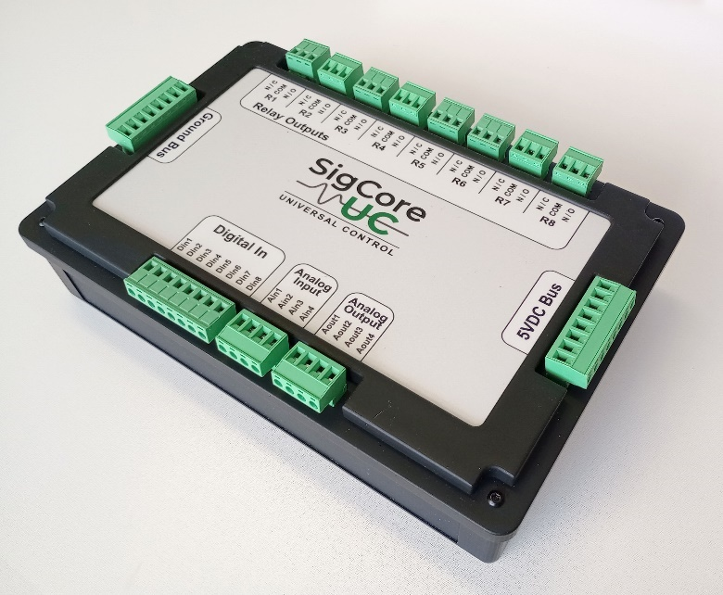
A Complete Industrial Control and Data Collection System
SigCore UC is a fully functional industrial control and data collection system. Unlike development boards or expansion modules, SigCore UC is a complete, ready-to-deploy solution — combining rugged hardware with powerful software in one package.
- 8 Relay Outputs – switch equipment and high-current loads
- 8 Universal Digital Inputs – ON: 2–24 VDC, OFF: 0–0.5 VDC
- 4 Calibrated Analog Inputs – voltage or current, with filtering and engineering units
- 4 Analog Outputs – voltage or PWM
- Built-in PID Control Loops – no extra coding required
- Modbus TCP Server – plus .NET and Python libraries
- Control Panel Software – full operational control, including PID settings
- Data Logging – record process data for analysis and optimization
Evaluation units are available now.
For review samples, specs, and high-resolution images, please contact:
Edward Schmitz
■ en Z em | SigCore UC
■ edwardschmitzsoftware@hotmail.com
■ 805-650-2101
■ https://sigcoreuc.com
________________________________________________________________________
sigcoreuc.com

